**BSc in Computing & BSc in Computing (Hons)**

**with**

**Multimedia**

**Games Development**

**Software Development**

**Mobile Apps Development**

**Information Technology Support**

### digital imaging & Digital Interfaces

**CONTINUOUS ASSESSMENT - SUBMISSION 2 – 15%**

**Date Given Out:** **Week 4 Lab 1** **Due Date: Week 6 Lab 2**

**Lecturer:** **Ms Marguerite O Mahony**

Design and create a launcher icon measuring 128px by 128px, please see below for tips on creating launcher icons and information on launcher icon sizes.

The brief is to create a launcher icon to represent an app that you have created or intend to create. Design a custom icon graphic for placement on the background.

Using all the tools and techniques used to date including – drawing tools, shapes, colour, layer styles, selections, or any other relevant techniques etc.

These are to be printed and placed in your scrapbook and also submitted digitally at the beginning of class in Lab 2 in week beginning 21st October 2013 (class before Reading/Study Week).

**ASSESSMENT CRITERIA**

Visual Research

Drawing Tools

Shapes

Colour

Type, if appropriate

Layer Styles/Layers/Blends

**Widget Icon Sizes**

Different platforms use different sizes for launcher icons, ranging from 16×16 to 128×128 – see below

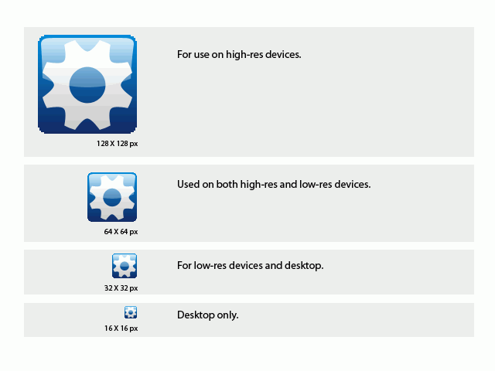

The default launcher icon sizes and their uses

You should supply icons for these different sizes to ensure the look and feel of your launcher icon maintains a high quality on several platforms.

**Tips for creating widget icons:**

* You should prepare icon graphics (the motif) for all icon sizes with a transparent background.
* Excluding the space needed for the background, the **launcher icons motifs** should typically be 12–14, 25–29, 50–58 and 100–116 pixels big. (Leave a margin around the outside: 2-3 pixels all around.)
* Save for web as PNG-8, 256 colors, selective, pattern, transparent.

**Research:**

Do you think the launcher icon needs text? Do research on that.

Concentrate on research.